SQL ASSIGNMENT 1
- Create Database e_commerce
- Create Database e_commerce;
use e_commerce;
show databases;
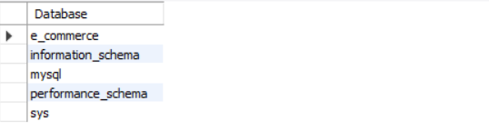
---------------------------------------------------------------------------------------------------
- Create following Tables:
Customers:
- customer_id - int auto-increment primary key
- name - varchar(50)
- email - varchar(50)
- mobile - varchar(15)
Products:
- id - int
- name - varchar(50) not null
- description - varchar(200)
- price - decimal(10, 2) not null
- category - varchar(50)
- Customers:
CREATE TABLE Customers (
customer_id INT AUTO_INCREMENT PRIMARY KEY,
name VARCHAR(50),
email VARCHAR(50),
mobile VARCHAR(15)
);

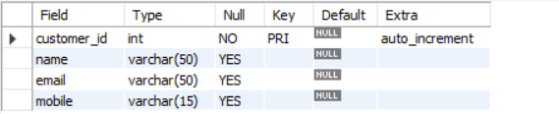

- Products:
CREATE TABLE Products (
id INT,
name VARCHAR(50) NOT NULL,
description VARCHAR(200),
price DECIMAL(10,2) NOT NULL,
category VARCHAR(50)
);

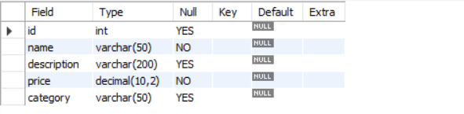
-------------------------------------------------------------------------------------------------------------
- Modify Tables(using Alter keyword):
a. Add not null on name and email in the Customers table => ALTER TABLE Customers MODIFY name VARCHAR(50) NOT NULL, MODIFY email VARCHAR(50) NOT NULL;

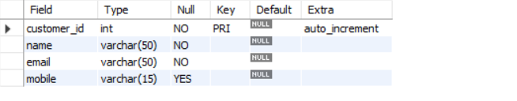
- Add unique key on email in the Customers table:
- ALTER TABLE Customers ADD CONSTRAINT u_email UNIQUE (email);
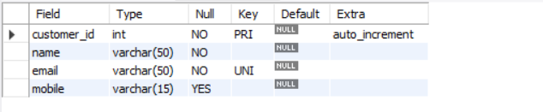
c. Add column age in the Customers table: => ALTER TABLE Customers ADD COLUMN age INT;
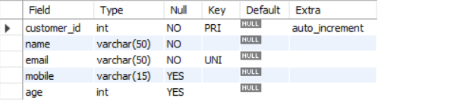

d. Change column name from id to product_id in the Products table;
=> ALTER TABLE Products CHANGE COLUMN id product_id INT;
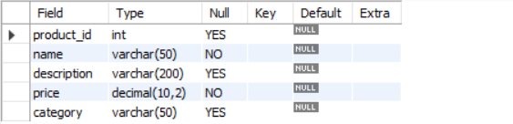
e. Add primary key and auto increment on product_id in the Products table
=> ALTER TABLE Products MODIFY COLUMN product_id INT AUTO_INCREMENT PRIMARY KEY;
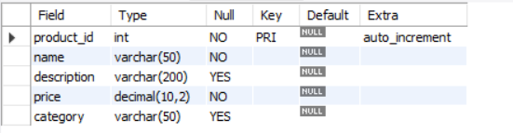
f. Change datatype of description from varchar to text in the Products table:
=> ALTER TABLE Products MODIFY COLUMN description text;
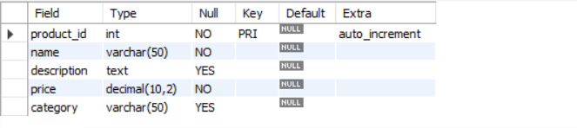
-------------------------------------------------------------------------------------------------------------------------
- Create table Order:
- order_id - int auto-increment primary key
- customer_id - int -foreign key
- product_id - int
- quantity - int not null,
- order_date - date not null,
- status - enum(Pending, Success, Cancel),
- payment_method - enum(Credit, Debit, UPI),
- total_amount - decimal(10, 2) not null

- CREATE TABLE Orders (
order_id INT AUTO_INCREMENT PRIMARY KEY,
customer_id INT,
product_id INT,
quantity INT NOT NULL,
order_date DATE NOT NULL,
status enum('Pending', 'Success', 'Cancel'),
payment_method enum('Credit', 'Debit', 'UPI'),
total_amount decimal(10,2) NOT NULL
);

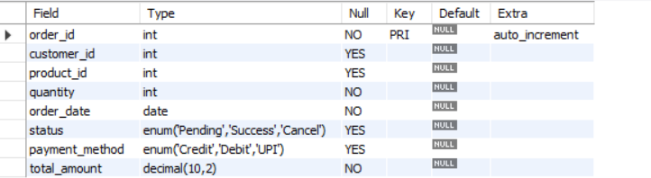
----------------------------------------------------------------------------------------------------------------------------
- Modify Orders Table(using Alter keyword):
- Change table name Order -> Orders
- ALTER TABLE Order RENAME TO Orders;
- Set default value pending in status.
- ALTER TABLE Orders MODIFY COLUMN status ENUM('Pending', 'Success', 'Cancel') DEFAULT 'Pending';
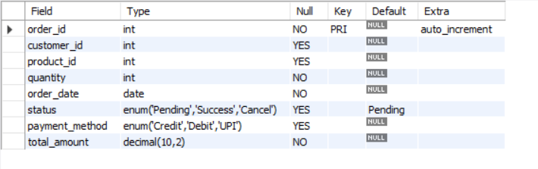
- Modify payment_method ENUM to add one more value: 'COD'
- ALTER TABLE Orders MODIFY COLUMN payment_method ENUM('Credit', 'Debit', 'UPI', 'COD');
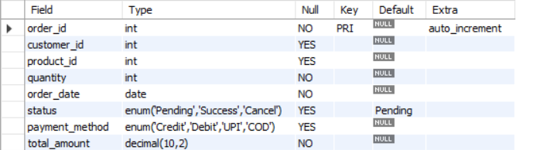
- Make product id as foreign key
- ALTER TABLE Orders ADD CONSTRAINT fk_orders_product FOREIGN KEY (product_id) REFERENCES Products(product_id);
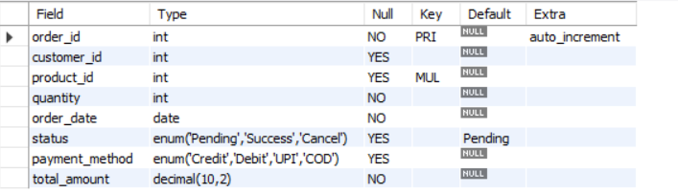
----------------------------------------------------------------------------------------------------------------------------
6. Insert 20 sample records in all the tables.
=>
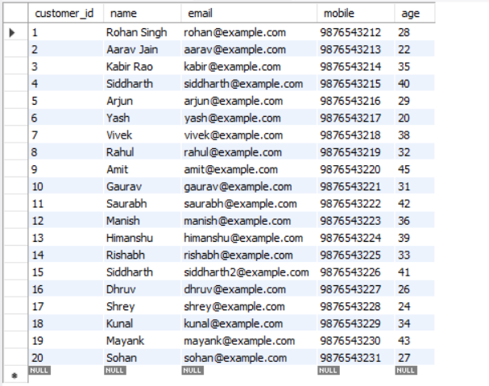

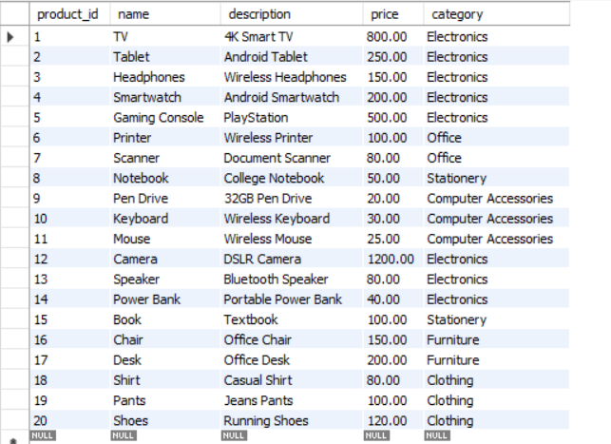

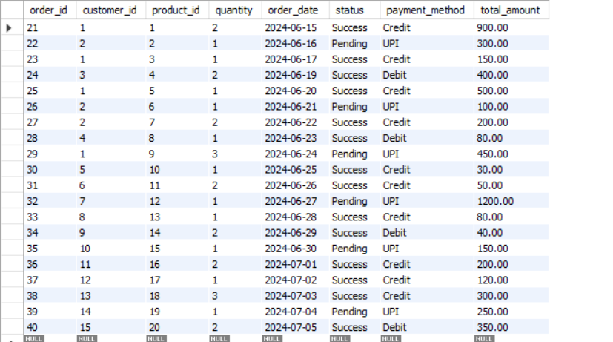
----------------------------------------------------------------------------------------------------------------------------
7. Perform following queries:
- Count the number of products as product_count in each category.
- SELECT category, COUNT(*) AS product_count FROM Products GROUP BY category;

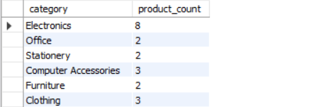

- Retrieve all products that belong to the 'Electronics' category, have a price between $50 and $500, and whose name contains the letter 'a'.
- SELECT * FROM Products WHERE category = 'Electronics' AND price BETWEEN 50 AND 500 AND name LIKE '%a%';
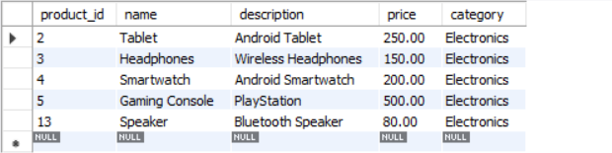
- Get the top 5 most expensive products in the 'Electronics' category, skipping the first 2.
- SELECT * FROM Products WHERE category = 'Electronics' ORDER BY price DESC
LIMIT 5 OFFSET 2;

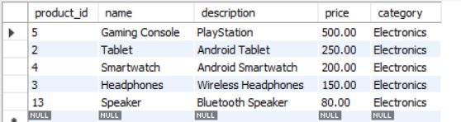

- Retrieve customers who have not placed any orders.
- SELECT * FROM Customers WHERE customer_id NOT IN (SELECT DISTINCT customer_id FROM Orders);
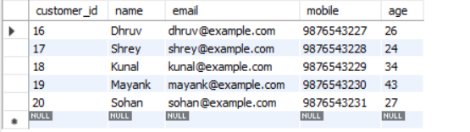
- Find the average total amount spent by each customer.
- SELECT customer_id, AVG(total_amount) AS avg_spent FROM Orders GROUP BY customer_id;

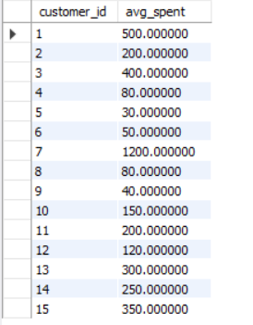
- Get the products that have a price less than the average price of all products.
- SELECT * FROM Products WHERE price < (SELECT AVG(price) FROM Products);

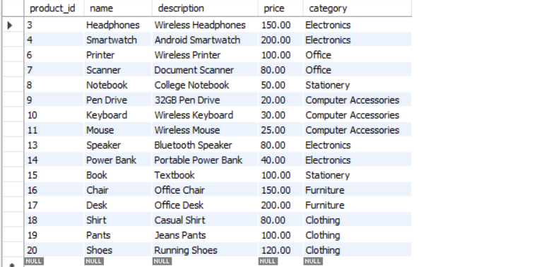

- Calculate the total quantity of products ordered by each customer:
- SELECT customer_id, SUM(quantity) AS total_quantity FROM Orders
GROUP BY customer_id;
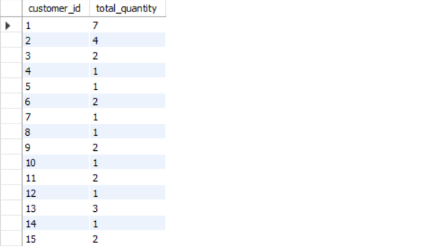

- List all orders along with customer name and product name.
- SELECT Orders.order_id, Customers.name AS customer_name, Products.name AS product_name FROM Orders
INNER JOIN Customers ON Orders.customer_id = Customers.customer_id
INNER JOIN Products ON Orders.product_id = Products.product_id;

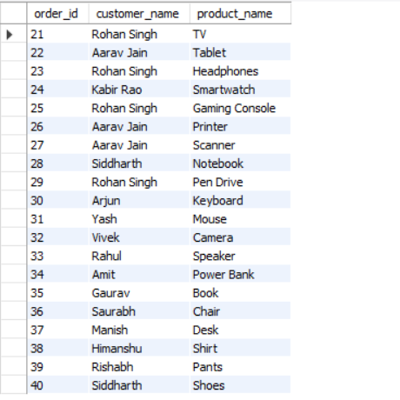

- Find products that have never been ordered.
- SELECT * FROM Products WHERE product_id NOT IN (SELECT DISTINCT product_id FROM Orders);
